***Punjab University College Of Information And Technology***



**Homework No (9)**

## Submitted By:

**Submitted To:**

**Imran Munawar MCSF19A027**

## Subject :

### Haq Nawaz

**Mobile Computing**



***Animations***

# Animations with reference of Image..

**Add ImageView:**

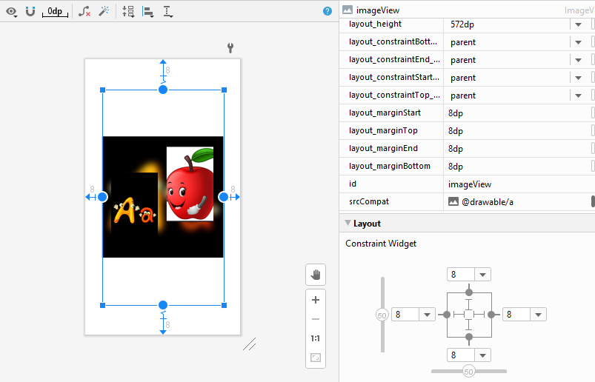

**Some Basic Functions of Animations:**

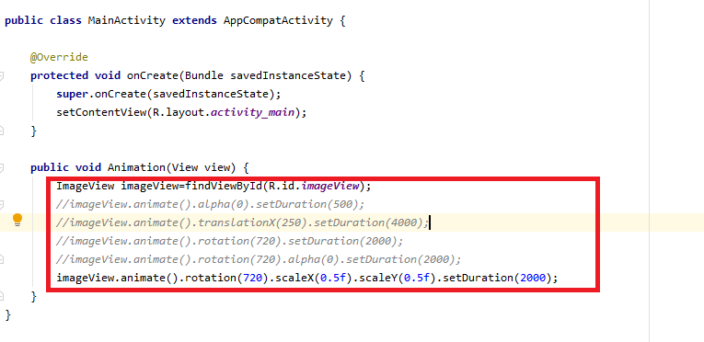

**Add new Activity:**

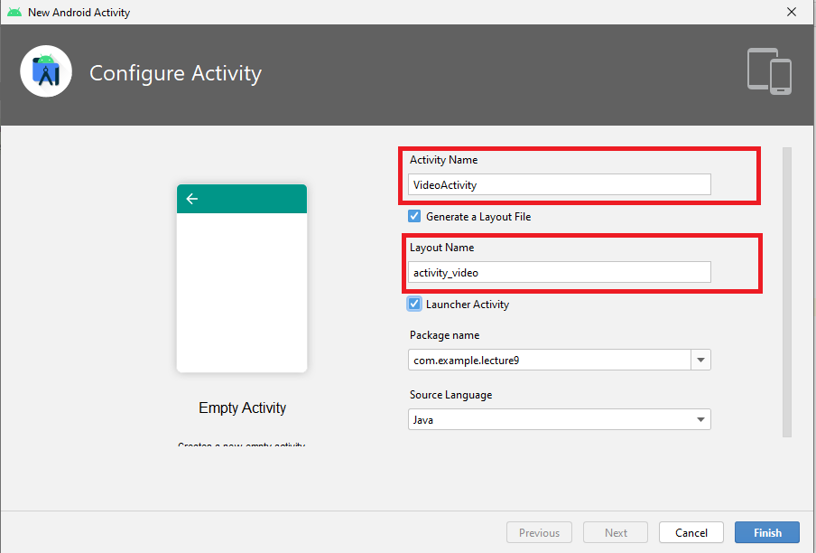

matn t:: java t:: com t:: a ample t:: lectured t:: c VideoActtvtty A BPP ” @ OPPO CPH1825 • ¥•

|  |  |  |  |  |  |  |
| --- | --- | --- | --- | --- | --- | --- |
| -c | An.» | 0 | — g/jyjty mgjp|,ym| | C MainActivity.java | activity video.xml | C VideoActivity.java |
|  | + |  |  | g Module |  |  |



copy Sample Data Directory

g 0 ‹t.i. - File

- Scratch File Ctrl+ AIt+ Shift+ Insert

Find Usages

Find in Path...

¿ Replgce in Path...

Analyge Refactor

Add to Fgvorites Reform at Code Optimize Imoorts

¥' Run ’All Tests’

* @ Debug ’All Tests’

“ Ip Run ’All Tests’ with Coyerag e

•• 4f Create ’All Tests’... Show in Explorer Directory Path

m M Open in Terminal

package com.example.lecture9; o & New Resource Directory

Resource type: raw

, Available qualifiers:

. Network Code

_ S ) ' Locale

@ Layout Direction

gg Smallest Screen Width

@ Ratio

*@* Orientation @ UI Mode

fi ' Night Made Density

Alto F7 Directory Ctrl+ Shift+ F

Ctrl+ Shift+ R • C++ Class

y #++ C/C++ Source File

C/C++ Header File a Image Asset

- Vector Asset

Ct’I Alt L g Kotl)n Scr)ot

Ct’I Alt 0 g Kotlin Worksheet

Ctrl+ Shift+ F10 = Activity

a Fragment a Folder



a UiComponent Ct’I+ Alto F12 a Automotive

N XML















Chosem quatiWers:

:e) (









# Add Video:

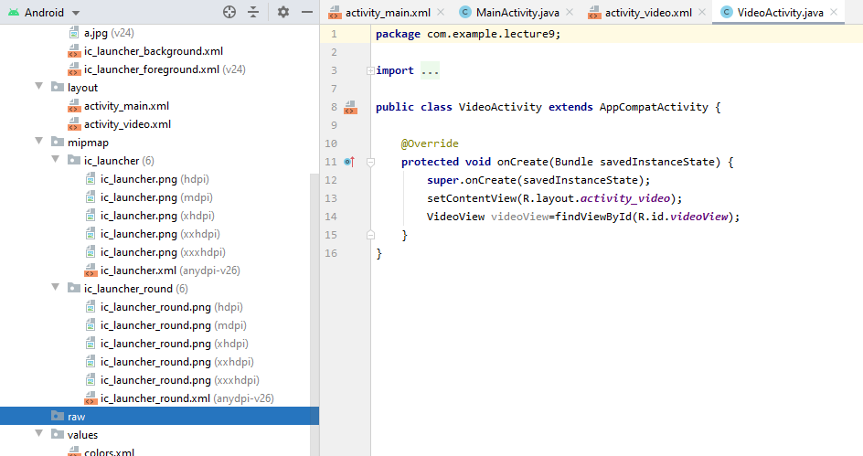

**Code Files of “VideoActivity” :**

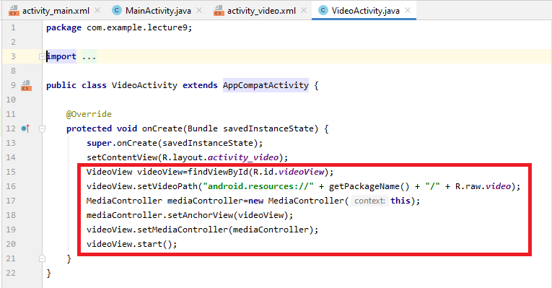

**Add new Activity:**

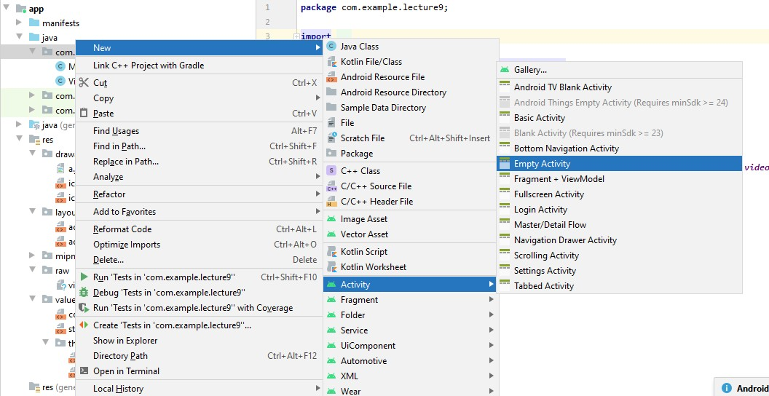

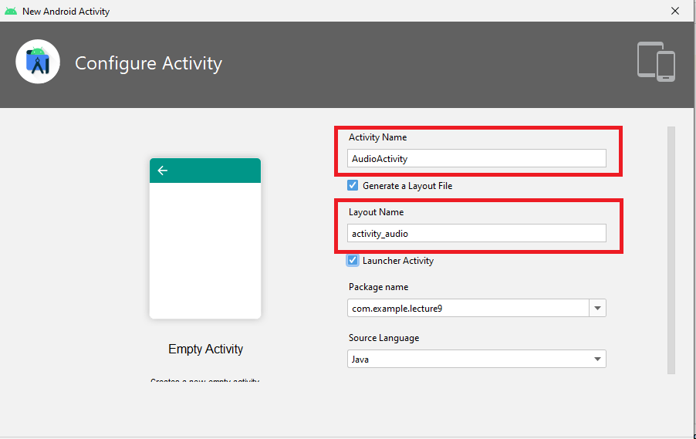

**GUI Files of “AudioActivity”:**

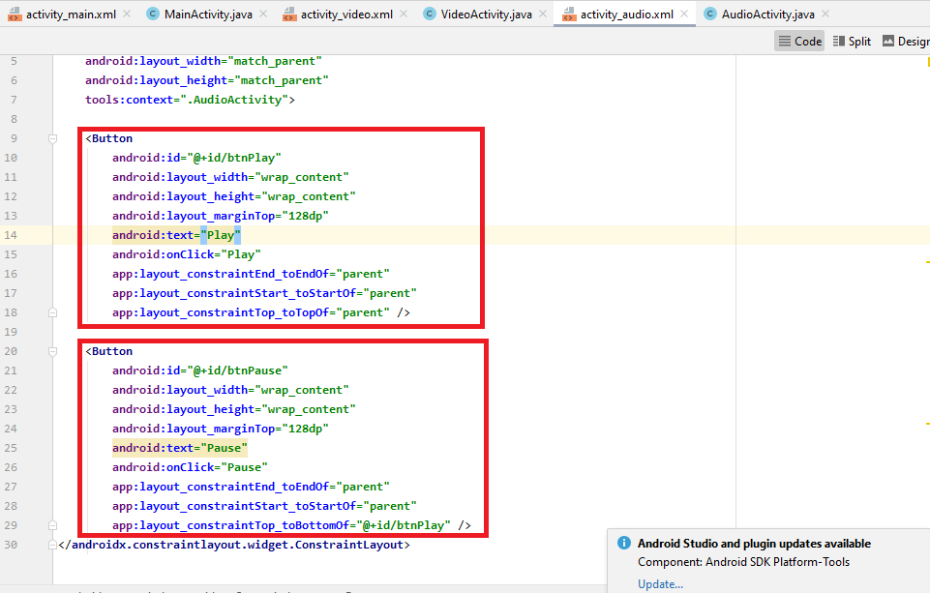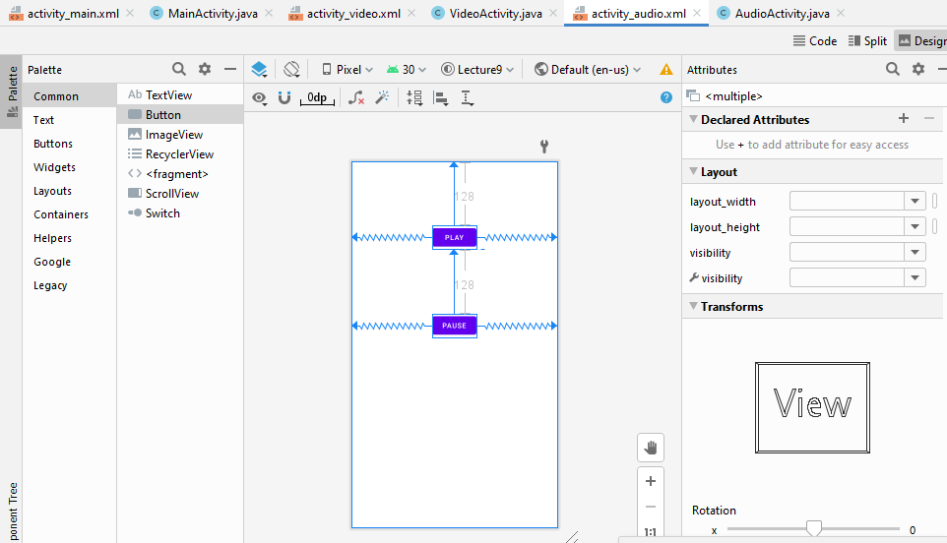

**Code Files of “AudioActivity”:**

